Task4

1. Save and ‘Play’. Click the tab ‘Console’ in the ‘Project’ view. What messages do you get? Then start playing by pressing arrow keys and notice change of the output.

As shown in the figure below, when ‘WASD’ is pressed, the output information changes

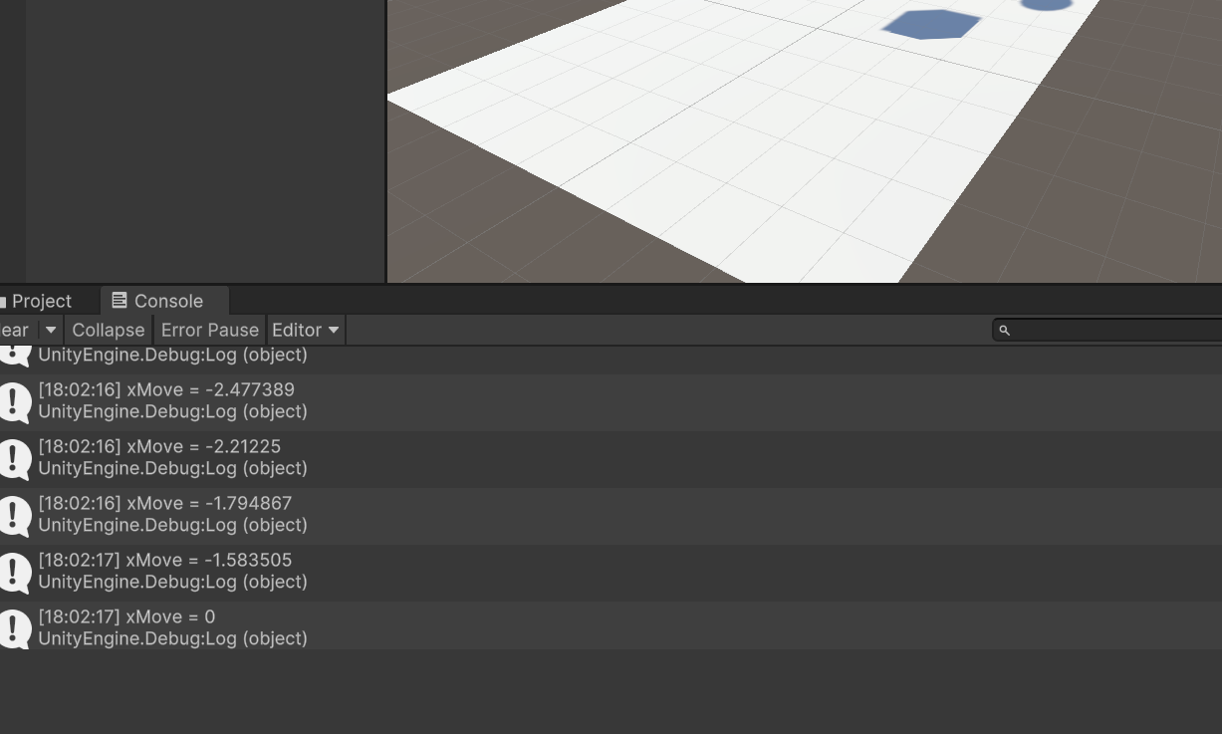

1. Use mouse to transform (move or rotate) the ‘Cube’.

As shown in the figure below, When the left mouse button clicks, it gives the object an upward force, while when the right button clicks, the opposite is true.

When there is no gravity, the up and down of the object can be manipulated in this way. However, when gravity is present, the effect of this method is not obvious. So, during the test, I canceled the gravity of the rigid body, which left the object afloat.

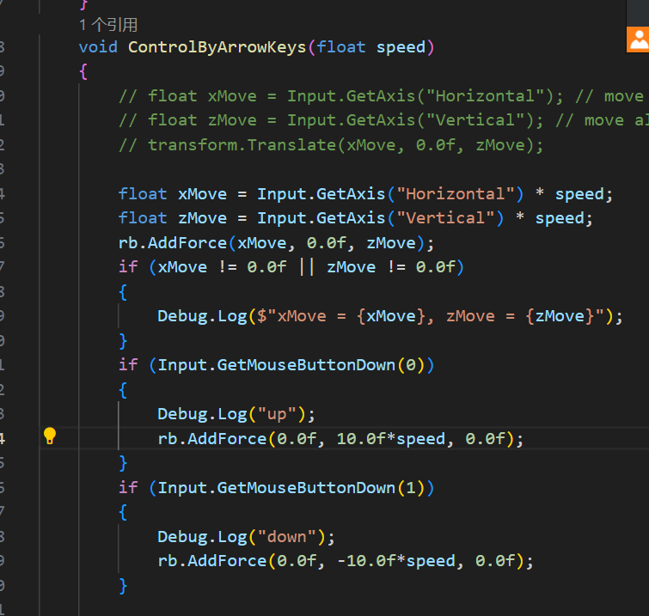

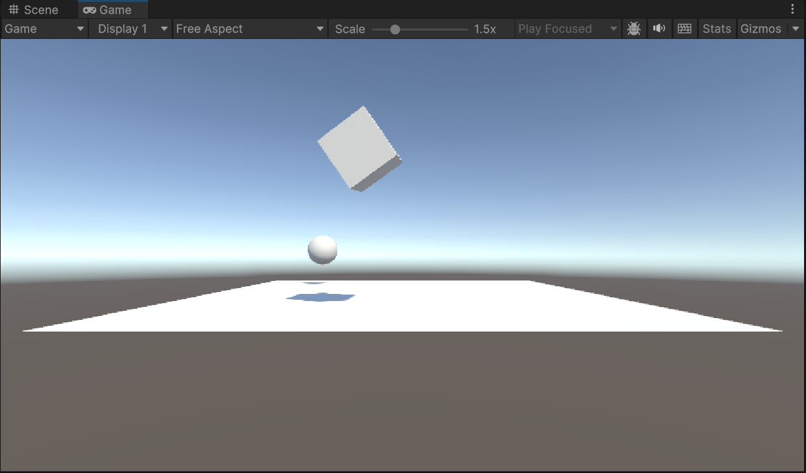

1. Use other keys to increase or decrease the ‘speed’, instead of going through the editor.

As shown in the figure below, the speed is controlled by detecting the plus key and the minus key.

